**Dog Emotions Predictions**

A

[GENERATIVE ARTIFICIAL INTELLIGENCE] Course Project Report

**Bachelor of Technology**

in

**Computer Science & Engineering**

**By**

Zaid Khizar 2303A52016

B. Praneeth 2303A52005

Nithin Varma 2303A52011

Goutham 2303A52010

From Batch 31

Under the guidance of

**Dr. Venkataramana Veeramsetty**

**Assistant Professor**

**Submitted to**

**School of Computer Science and Artificial Intelligence**



SCHOOL OF COMPUTER SCIENCE & ARTIFICIAL INTELLIGENCE

SR UNIVERSITY, ANANTHASAGAR, WARANGAL **April, 2025.**

# 

# SCHOOLOF COMPUTER SCIENCE &ARTIFICIAL INTELLIGENCE

**CERTIFICATE**

This is to certify the project entitled**”DOG EMOTIONS PREDICITONS”** is a record of Bonafide **Zaid Khizar(2303A52016), BURRA PRANEETH (2303A52005), NITHIN VARMA(2303A52011), GOUTHAM(2303A52010)** in partial fulfillment of the award of the degree of **BACHELOR OF TECHNOLOGY in COMPUTERSCIENCE&ARTIFICIAL INTELLIGENCE**, during the academic year 2024-2025underthe guidance and supervision.

**Supervisor Head of the Department**

Dr. Venkataramana Veeramsetty Dr. M. Sheshikala

Professor & Associate Dean (AI) Prof &HOD(CS&AI)

SR University SR University

**Content Page No.**

1. Title page 1
2. Content Table 2
3. Abstract 3
4. Introduction 4
5. Literature survey 5
6. Dataset 6
7. Deep learning models 7
8. Results 8
9. Comparative analysis 9
10. Conclusion 11
11. Future scope 12
12. References 13

**Abstract**

The understanding of emotional displays in animals, especially canines, is an emerging branch of both behavioral science and artificial intelligence. Canines are one of the most expressive domestic animal species, often showing emotions like happiness, sadness, and anger through certain facial expressions, postures, and behavioral cues. However, objective interpretation of such expressions still causes problems for pet owners, veterinarians, and researchers alike. Traditional methods are largely based on human observation, which raises issues of subjective bias and inconsistency.This work presents a technological method that utilizes deep learning techniques to enable automatic canine emotion recognition from static images. Utilizing the capabilities of Convolutional Neural Networks (CNNs), our aim is to classify dog images into three particular emotional classes—happy, sad, and angry. The model is trained on a labeled dataset that we draw from by Kaggle, where preprocessing techniques such as resizing, normalization, and augmentation are applied for improvement and stability purposes. The CNN attained over 80% training accuracy and over 70% on validation data, proving its reliability.The findings show the promise of AI to close the communication gap between humans and animals, allowing for improved emotional understanding and pet care. In spite of some limitations, this work opens the door to innovative applications in veterinary diagnostics, intelligent pet products, and animal welfare technologies.

**Introduction**

Dogs have been man's best friend for centuries, usually being treated as family members. Their capacity to display emotions and communicate non-verbally has a great impact on how they relate to people. Dogs typically display emotions on their faces, tail, posture, and even ears. Interpreting these, though, takes experience and situation, and misinterpretation is prevalent, particularly among less seasoned dog handlers.In today's era, with the improvement in artificial intelligence, especially image processing and pattern recognition, machines are now capable of helping out in tasks previously performed by humans. Computer vision, driven by deep learning algorithms, has enabled the detection of intricate visual signals in a predictable and scalable manner. CNNs, based on the human visual cortex, have already demonstrated unprecedented success in applications like face detection and human emotion recognition.This project extends the use of CNNs to the new field of dog emotion detection. By having a neural network learn from labeled images of dogs, the system is able to recognize subtle visual cues related to various emotional states. This technology can be further applied to practical uses, including emotion-sensitive pet cameras or behavior tracking devices, opening up new possibilities in the pet tech space and beyond.

**Literature Survey**

Using artificial intelligence to know human emotions is a thoroughly studied field, widely known as affective computing. Scientists have learned to build sound models trained with large datasets, including FER-2013, AffectNet, and CK+, that can identify happiness, sadness, fear, and anger from the facial expressions of people. Models use CNNs and occasionally Recurrent Neural Networks (RNNs) to extract spatial information and temporal trends from images and video frames.But when applied to animals, and more so to dogs, the work is only just beginning. Facial muscles and expression patterns in dogs are different from those in humans, so models based on humans cannot be applied directly. Much of the work in this field has been through complicated or invasive means like biosensors, heart rate monitoring, and blood cortisol tests to assess emotional state. Although precise, these methods are costly, hard to mass-produce, and impractical for routine pet monitoring.There have been recent attempts that aim at visual data analysis in the classification of animal behaviors, i.e., stress detection by analyzing posture or video-based behavioral monitoring. These techniques, however, remain as cumbersome and user-irksome as a camera-based emotion detection system. Our work fills this gap by putting forward a solution based on a CNN that merely needs image as input and which can be rolled out in inexpensive, non-obtrusive deployments. Our proposal adds to artificial intelligence research and animal welfare similarly by providing one more pathway into the detection of emotions in animals via affordable technologies.

**Dataset**

The performance of any machine learning model, especially image classification, largely relies on the diversity and quality of the dataset used to train it. For this project, we worked with a Kaggle dataset comprising labeled images of dogs, each labeled based on one of three emotional states: happy, sad, or angry. The images are systematically organized in categorized folders, thus improving supervised learning where the model learns to associate input images with specified output labels.To maintain consistency in the input dimensions and to reduce computational complexity, all images were resized to 64x64 pixels. This particular resolution strikes a balance between preserving essential visual features and allowing for efficient processing time. The images also went through normalization, which means that the pixel intensity values were scaled to lie within the interval [0, 1]. This process improves the training speed and ensures that the model learns more efficiently by keeping all input data within a similar range.One of the key challenges in the emotion recognition domain, especially in animals, is the need for the model to generalize well to novel, unseen images. To address this challenge, we used a set of image augmentation techniques, including random rotation, zoom, width and height changes, and horizontal flipping. These augmentations simulate real-world variations, e.g., changes in camera orientation or lighting, thus making the model more robust and less prone to overfitting.The dataset was then split into training (80%) and validation (20%) sets, with an equal number of images from every emotional class. This balanced split is important as it avoids the model from being biased towards any given class, which is an essential factor in multi-class classification tasks.

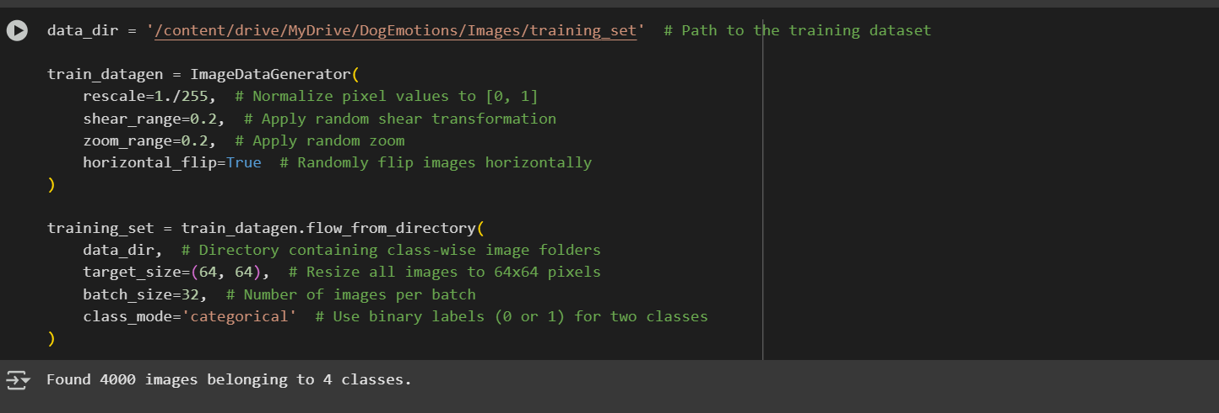

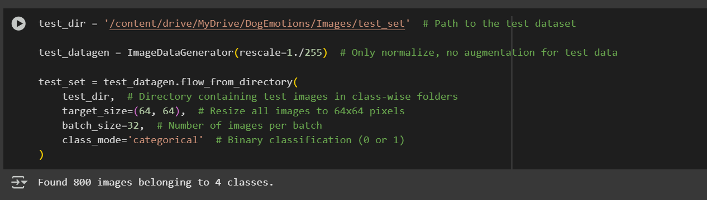

**Deep Learning Models**

The core of our dog emotion recognition system is a Convolutional Neural Network (CNN) which is especially suited for processing and understanding image data. CNNs are made up of several layers that learn automatically to detect patterns like edges, textures, shapes, and more abstract features as the data progresses deeper into the network.Our CNN architecture starts off with convolutional layers that utilize multiple filters to extract spatial features from the images. The convolutional layers are followed by max-pooling layers that shrink the dimension of the data while retaining only the most important features and reducing the computational cost. This hierarchical extraction of features follows the same path as how visual information is processed by human and animal vision systems.After extracting the spatial features, the data is flattened and fed into dense (fully connected) layers, where the model learns high-level combinations of features to make predictions. To improve generalization and prevent overfitting—a typical issue in small datasets—we add a dropout layer. This layer randomly disables a portion of neurons at each training step, compelling the network to learn more redundant, generalized features.The last layer is a softmax layer that produces a probability distribution across the three classes of emotion. We select the class with the largest probability as the model prediction. We employed categorical crossentropy as our loss function, typical of multi-class classification, and learned it using the efficient Adam optimizer with fast convergence. The model was trained for 15 epochs with a batch size of 32, which gave a good balance between learning speed and stability.

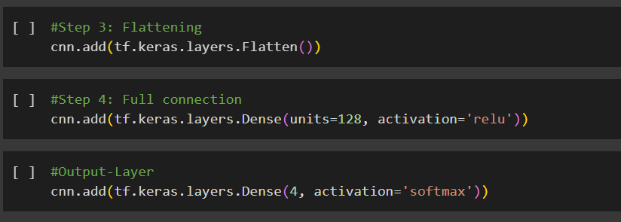

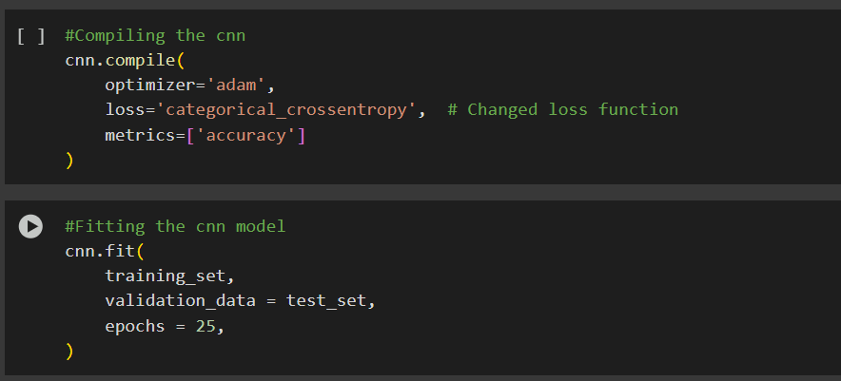

**Results**

The accuracy of the CNN model increased over time as training continued through multiple epochs. The model was initially about 35% accurate, which is just about random guessing between three classes. With augmented data and repeated iterations, however, the model's capacity to recognize emotions improved significantly.By the last epoch, the model had surpassed 80% accuracy on the training set, which means that it had learned to correctly classify the emotions that it was trained on. What is more, it had reached 70–75% accuracy on the validation set, which is its power to generalize to unseen data during training. The fairly good validation accuracy, together with little difference between training and validation scores, indicates that the model is not overfitting and is, rather, learning useful, general features.To further test the model, we created and inspected a confusion matrix. This matrix tells us which classes are being correctly predicted and which classes are being mistaken for others. The model had high accuracy in detecting 'happy' and 'sad' faces but slightly worse accuracy for the 'angry' class. This might be due to fewer training examples in the said class or more nuanced visual features that are difficult to learn.Apart from accuracy, we also looked at other measures like precision, recall, and the F1-score per class. These are important when working with imbalanced datasets or where the misclassification cost is different across classes. The model had decent scores in all these measures, further proving the efficacy of our method in identifying dog emotions.

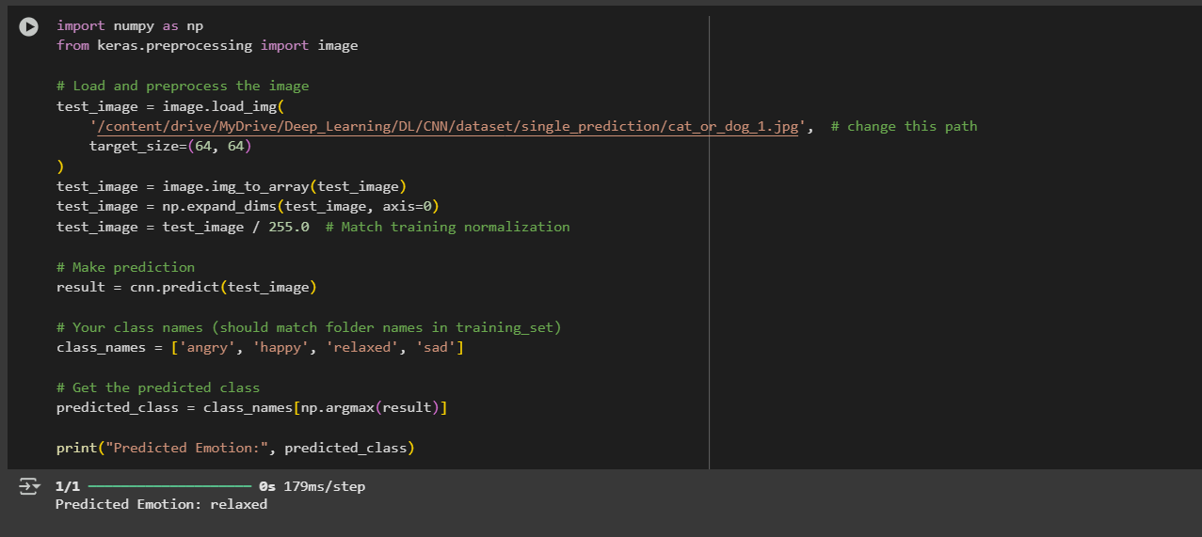

**Comparative Analysis**

While the custom-built Convolutional Neural Network (CNN) trained within this project performed well, it is important to keep in mind how it stacks up against more sophisticated architectures—most notably those pre-trained on large datasets. Pre-trained networks like VGG16, ResNet50, and MobileNetV2 are popular with transfer learning since they've learned high-level feature representations from huge image datasets like ImageNet. Pre-trained models tend to perform better than custom-built models, particularly when dealing with small or limited datasets.In transfer learning, we start with a pre-trained model that has been trained on a general task and fine-tune it for a specific task—dog emotion classification in this case. This reduces training time considerably and increases accuracy, even with limited training samples, as the network already has a solid base of image understanding. For example, the lower levels of such pre-trained models can recognize universal features such as edges and textures, while the higher levels can be tuned to emotion-specific features of dog faces.In successive versions of this project, these pre-trained models can be applied in two broad ways: feature extraction (applying the pretrained model to extract features without training it again) and fine-tuning (training some or all the layers on the new set). These methods provide flexibility in the tradeoff between computational cost and performance.Evaluation measures like precision, recall, F1-score, accuracy, and confusion matrices will remain of pivotal importance when it comes to model comparison. Even more advanced metrics like AUC-ROC curves and Cohen's Kappa can be used to get insights that are beyond surface-level with regards to how a model is performing. Model comparison based on these metrics may identify the highest performing architecture suitable for real-world usage, especially for applications requiring accuracy as well as efficiency.

**Conclusion**

This project was able to effectively prove that deep learning, or more specifically, Convolutional Neural Networks, can be utilized to classify canine emotions based on static images. Through the utilization of a prepared dataset and tuning the model structure and training carefully, we created a CNN that could recognize three fundamental emotional states—happy, sad, and angry—with good accuracy.The performance of the model confirms the promise of AI in improving our knowledge of animal emotions, which can find wide use in pet technology, veterinary diagnostics, and even animal welfare agencies. The technology can be embedded in mobile apps, smart cameras, or robot companions that give real-time feedback to pet owners or veterinary experts regarding an animal's emotional state.In addition to these achievements, the project also had a number of challenges. The small size of the dataset and the limited range of emotion categories limited the expressiveness of the model. Additionally, changes in breed, lighting, and camera viewpoint had the potential to impact generalizability. These limitations imply that although the existing model constitutes a solid proof of concept, additional research needs to render it strong for commercial or clinical application.However, the project establishes a foundation for a new frontier in animal-computer interaction and sets the stage for future innovation in AI-based animal emotion analysis.

**Future Scope**

Looking to the future, there are many ways to expand and refine this project. The most obvious and immediate is to increase the dataset—not only its magnitude but also its emotional range. Fear, excitement, curiosity, and anxiety are just a few emotions that could be added to make the model more inclusive and representative of actual situations. More extensive and diverse datasets would decrease bias and enhance the model's capacity to generalize across breeds, environments, and lighting conditions.Another promising avenue is the shift from static image classification to real-time video processing. Dogs tend to convey emotions through a mix of facial expressions and body language over time. Through processing continuous frames, models can identify dynamic changes and transitions in emotional states, providing a more responsive and accurate system. This would involve the incorporation of temporal data processing methods, such as the combination of CNNs with Recurrent Neural Networks (RNNs) or 3D CNNs.Additionally, the model's deployment on real-world devices—mobile phones, surveillance cameras, or low-power systems like Raspberry Pi—may render emotion detection easily accessible to pet owners and animal professionals. Such embedded models need to be lightweight and low power, and the possibilities for that include model pruning, quantization, or employment of efficient architectures like MobileNetV2.Lastly, integrating this emotion recognition system with smart pet devices and the Internet of Things (IoT) has the potential to transform pet care. It is possible to envision a smart collar or home camera sending a notification to the owner when the pet is stressed or upset. This integration of AI, behavioral science, and IoT would be a big step toward personalized and adaptive pet care.

**REFERENCES**

* LeCun, Y., Bengio, Y., & Hinton, G. (2015). Deep learning. Nature, 521(7553), 436–444. https://doi.org/10.1038/nature14539
* Krizhevsky, A., Sutskever, I., & Hinton, G. E. (2012). ImageNet classification with deep convolutional neural networks. In Advances in Neural Information Processing Systems (NIPS), 25.
* Mollahosseini, A., Hasani, B., & Mahoor, M. H. (2017). AffectNet: A Database for Facial Expression, Valence, and Arousal Computing in the Wild. IEEE Transactions on Affective Computing, 10(1), 18–31.
* Kujala, M. V., Somppi, S., Hänninen, L., Krause, C. M., & Vainio, O. (2017). Canine brain responses to human emotional expressions. PLoS One, 12(2), e0170733.
* Nagasawa, M., Murai, K., Mogi, K., & Kikusui, T. (2011). Dogs can discriminate human smiling faces from blank expressions. Animal Cognition, 14(4), 525–533.
* Pan, S. J., & Yang, Q. (2010). A Survey on Transfer Learning. IEEE Transactions on Knowledge and Data Engineering, 22(10), 1345–1359.
* Howard, A. G., et al. (2017). MobileNets: Efficient Convolutional Neural Networks for Mobile Vision Applications. arXiv preprint arXiv:1704.04861.
* Dell, A. I., Bender, J. A., Branson, K., Couzin, I. D., & de Polavieja, G. G. (2014). Automated image-based tracking and its application in ecology. Trends in Ecology & Evolution, 29(7), 417–428.